** OFFICE OF THE CANTONMENT BOARD HAVELIAN**

**MILITARY LANDS & CANTONMENTS DEPARTMENT (ML&C)**

**Landline # 0992-407392-7292 Website: cbhavelian.gov.pk**

**JOB APPLICATION FORM**

**Applied for the Post: ____________________________________**

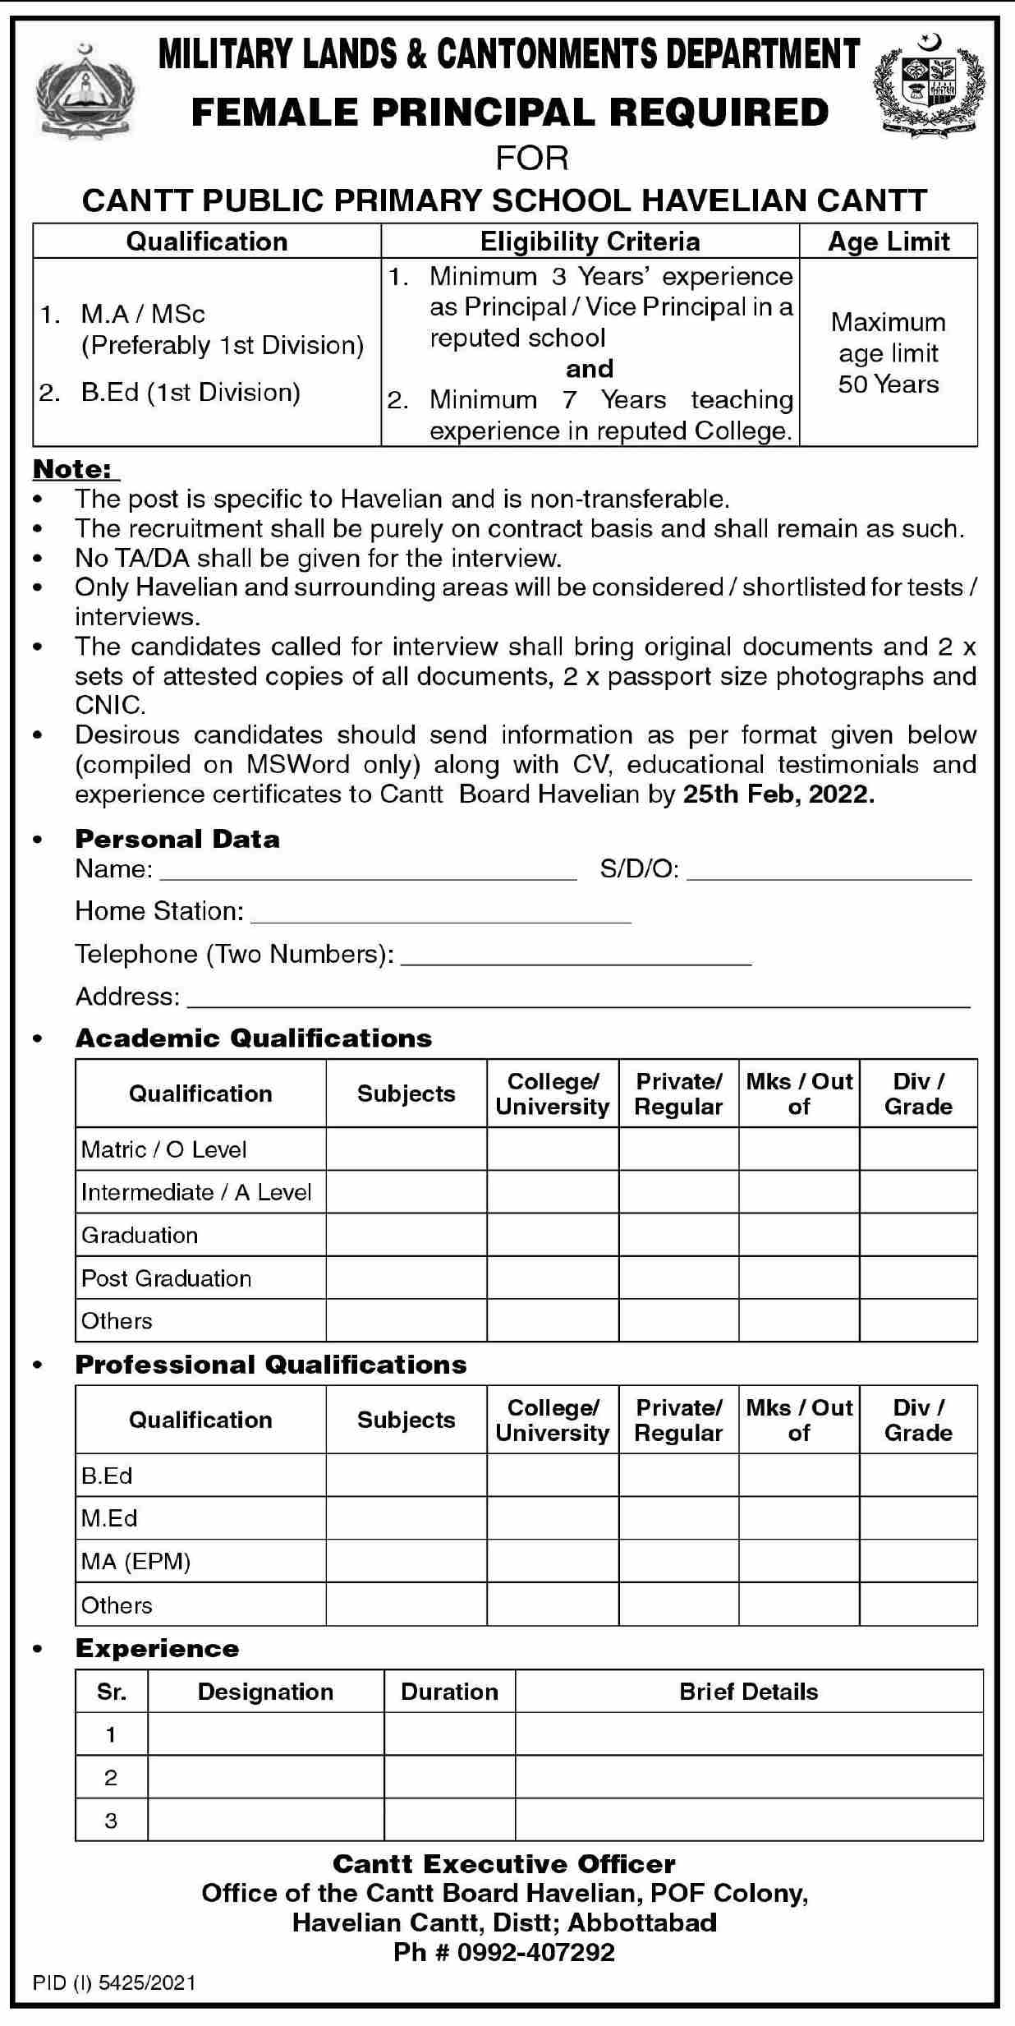

**Dated: Signature**



**Note:**